
Design Analysis of Algorithms
ENCA351

Lab Assignment -1

K. R. MANGALAM UNIVERSITY, GURUGRAM, HARYANA, INDIA

Submitted to: - Submitted By: -
Dr. Aarti Sangwan Varun Sain
2301201134

Ques: (i) Fibonacci – Naive Recursive
Sol.
- Computes F(n) by recursively summing F(n−1) and F(n−2).
- Conceptually simple but repeats overlapping subproblems heavily.
- Practical only for small n.

Time Complexity:
- Time: O(2^n) approximately
- Space: O(n) recursion depth

Code Section:
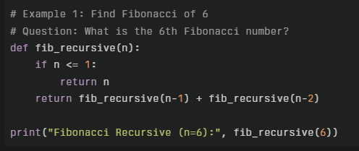

Output:


(ii) Fibonacci – Dynamic Programming (Tabulation)
Sol.
- Builds Fibonacci bottom-up in a DP array.
- Eliminates repeated computation, linear time.
- Easy to reason and implement.

Time Complexity:
- Time: O(n)
- Space: O(n) for DP array (can be reduced to O(1))

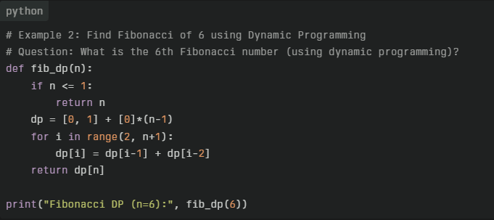
Code Section:


Output:

(iii) Merge Sort
Sol.
- Divide the array, recursively sort halves, then merge.
- Stable with guaranteed O(n log n) performance.
- Uses additional space to merge.

Time Complexity:
- Time: O(n log n) best/avg/worst
- Space: O(n)

Code Section:

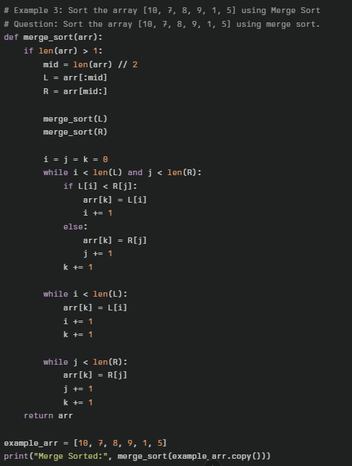

Output:

(iv) Quick Sort (Functional Partition)
Sol.
- Picks a pivot, partitions into less/greater, recursively sorts and concatenates.
- Average O(n log n), worst O(n^2) with bad pivots.
- Functional style is concise but not in-place.

Time Complexity:
- Best/Average: O(n log n)
- Worst: O(n^2)
- Space: O(n) due to lists created during partitioning

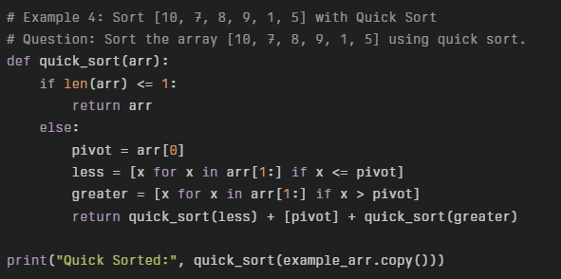
Code Section:

Output:

(v) Insertion Sort
Sol.
- Inserts each element into its correct spot among previous elements.
- Good for small or nearly sorted inputs.
- Quadratic behaviour on average.

Time Complexity:
- Best: O(n) nearly sorted
- Average/Worst: O(n^2)
- Space: O(1)

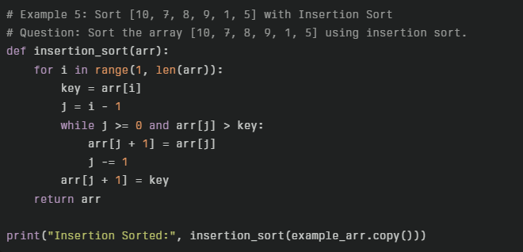
Code Section:

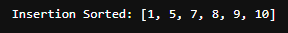
Output:

(vi) Bubble Sort
Sol.
- Repeatedly swaps adjacent inversions; simple but slow.
- Educational and easy to implement.
- Early stop if a pass makes no swaps (not shown here).

Time Complexity:
- Best: O(n) with early exit on sorted data
- Average/Worst: O(n^2)
- Space: O(1)

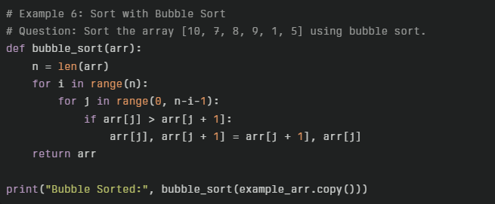
Code Section:

Output:

(vii) Selection Sort
Sol.
- Selects the minimum from the unsorted suffix and swaps into place.
- Fewer swaps but still quadratic comparisons.
- Works fine for small inputs.

Time Complexity:
- Time: O(n^2) best/avg/worst
- Space: O(1)

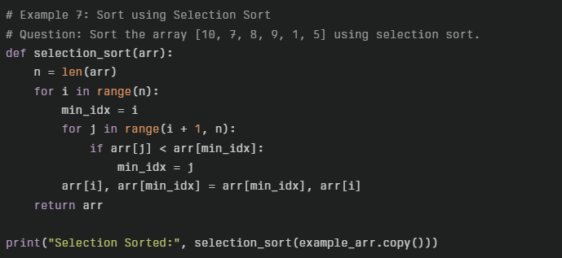
Code Section:

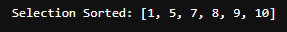
Output:

(viii) Binary Search
Sol.
- Searches a sorted array by halving the interval each step.
- Requires the input to be sorted first.
- Very efficient for lookups on sorted lists.

Time Complexity:
- Time: O(log n)
- Space: O(1) iterative

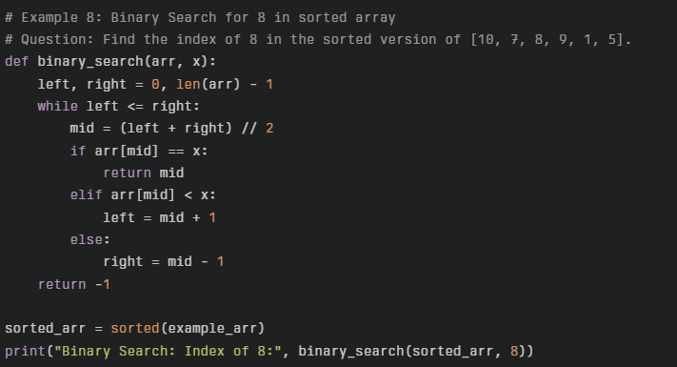
Code Section:

Output:


